**Industrial Internship Report on**

**Forecasting Smart city traffic**

**Prepared by**

**KUMARESAN A**

|  |
| --- |
| *Executive Summary* |
| This report provides details of the Industrial Internship provided by upskill Campus and The IoT Academy in collaboration with Industrial Partner Uni Converge Technologies Pvt Ltd (UCT).  This internship was focused on a project/problem statement provided by UCT. We had to finish the project including the report in 6 weeks’ time.  My project was Smart city traffic forecasting projects aim to create more efficient, sustainable, and resilient urban transportation systems by leveraging advanced technologies and data-driven insights. These initiatives contribute to reducing traffic congestion, improving air quality, and enhancing overall quality of life in urban areas.  This internship gave me a very good opportunity to get exposure to Industrial problems and design/implement solution for that. It was an overall great experience to have this internship. |

**TABLE OF CONTENTS**

1 Preface 3

2 Introduction 4

2.1 About UniConverge Technologies Pvt Ltd 4

2.2 About upskill Campus 8

2.3 Objective 9

2.4 Reference 9

2.5 Glossary 10

3 Problem Statement 11

4 Existing and Proposed solution 12

5 Proposed Design/ Model 13

5.1 High Level Diagram (if applicable) 13

5.2 Low Level Diagram (if applicable) 13

5.3 Interfaces (if applicable) 13

6 Performance Test 14

6.1 Test Plan/ Test Cases 14

6.2 Test Procedure 14

6.3 Performance Outcome 14

7 My learnings 15

1. Future work scope 16

# 

# 1 Preface

In terms of population and economic growth, India is the second-largest country. India's major cities are plagued by issues with traffic congestion. In wealthy nations, sustaining Intelligent Transport Management Systems (ITMS) is a realistic challenge, and enhancing urban areas is also fraught with challenges. One of the most significant issues facing India is this one. This is brought on by limited space, high costs, and delayed infrastructure growth compared to the quick rise in vehicle numbers. Traveller’s require traffic flow information to aid in better travel choices in congested areas and to increase the effectiveness of traffic operations. To manage motorway networks, it will be more beneficial to forecast short-term traffic flow. This traffic flow prediction uses real-time data to forecast traffic conditions for the next 5 to 20 minutes. Every nation on earth strives to make their traffic management system more effective. Different techniques have been employed by researchers to forecast motorway traffic in urban settings. The most prevalent issue in many of the emerging cities, despite the growth of transit services, is traffic congestion. With the fast expansion of the IT industry, both the population and the number of automobiles rose in major cities like Bangalore and Delhi. To control traffic congestion and notify drivers to choose alternate routes to avoid congestion and save time, a smart and intelligent traffic information system is needed. This is why India's urban regions need intelligent traffic systems (ITS).

Data science is the study of data with the goal of gaining important business insights. In order to examine enormous amounts of data, this multidisciplinary approach incorporates ideas and methods from the domains of mathematics, statistics, artificial intelligence, and computer engineering. Data scientists can ask and receive answers to questions like what occurred, why it occurred, what will occur, and what can be done with the outcomes thanks to this study. Machine learning is a subset of artificial intelligence (AI) that enables computers to learn from data without being explicitly taught, whereas data science combines tools, methodologies, and technology to derive meaning from data. Because it can find patterns and relationships in enormous volumes of data and base forecasts on these relationships, it is the perfect tool for predicting agricultural productivity

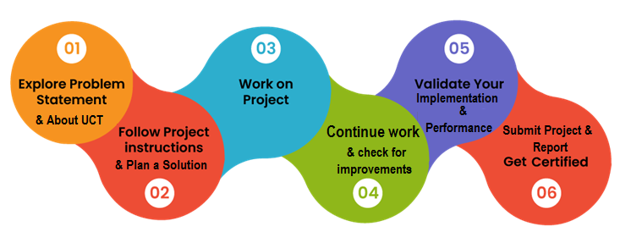

# Introduction

## 2.1 About UniConverge Technologies Pvt Ltd

A company established in 2013 and working in Digital Transformation domain and providing Industrial solutions with prime focus on sustainability.

For developing its products and solutions it is leveraging various**Cutting Edge Technologies e.g. Internet of Things (IoT), Cyber Security, Cloud computing (AWS, Azure), Machine Learning, Communication Technologies (4G/5G/LoRaWAN), Java Full Stack, Python, Front end**etc.



1. UCT IoT Platform **(****)**

**UCT Insight** is an IOT platform designed for quick deployment of IOT applications on the same time providing valuable “insight” for your process/business. It has been built in Java for backend and ReactJS for Front end. It has support for MySQL and various NoSql Databases.

* It enables device connectivity via industry standard IoT protocols - MQTT, CoAP, HTTP, Modbus TCP, OPC UA
* It supports both cloud and on-premises deployments.

It has features to  
• Build Your own dashboard  
• Analytics and Reporting  
• Alert and Notification  
• Integration with third party application (Power BI, SAP, ERP)  
• Rule Engine

 

1. **Smart Factory Platform (****)**

Factory watch is a platform for smart factory needs.

It provides Users/ Factory

* with a scalable solution for their Production and asset monitoring
* OEE and predictive maintenance solution scaling up to digital twin for your assets.
* to unleased the true potential of the data that their machines are generating and helps to identify the KPIs and also improve them.
* A modular architecture that allows users to choose the service that they what to start and then can scale to more complex solutions as per their demands.

Its unique SaaS model helps users to save time, cost and money.



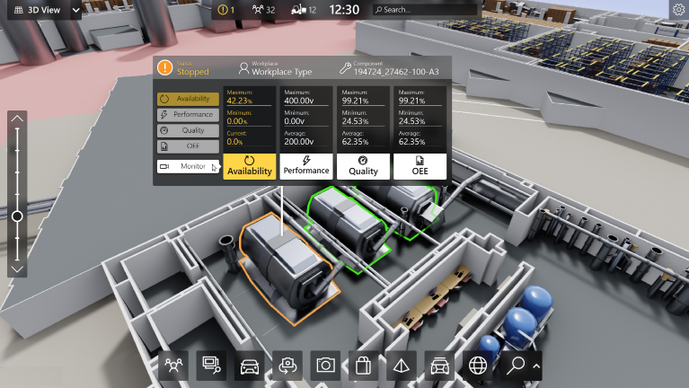

1.  based Solution

UCT is one of the early adopters of LoRAWAN technology and providing solution in Agritech, Smart cities, Industrial Monitoring, Smart Street Light, Smart Water/ Gas/ Electricity metering solutions etc.

1. Predictive Maintenance

UCT is providing Industrial Machine health monitoring and Predictive maintenance solution leveraging Embedded system, Industrial IoT and Machine Learning Technologies by finding Remaining useful life time of various Machines used in production process.



## About upskill Campus (USC)

upskill Campus along with The IoT Academy and in association with Uniconverge technologies has facilitated the smooth execution of the complete internship process.

USC is a career development platform that delivers **personalized executive coaching** in a more affordable, scalable and measurable way.



Seeing need of upskilling in self -paced manner along-with additional support services e.g. Internship, projects, interaction with Industry experts, Career growth Services

<https://www.upskillcampus.com/>

UpSkill Campus aiming to upskill 1 million learners in next 5 year

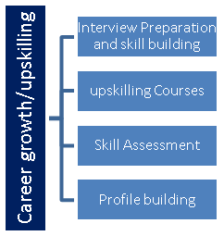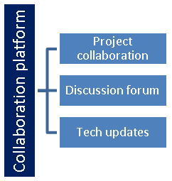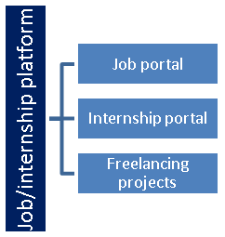

## The IoT Academy

The IoT academy is EdTech Division of UCT that is running long executive certification programs in collaboration with EICT Academy, IITK, IITR and IITG in multiple domains.

## Objectives of this Internship program

The objective for this internship program was to

 ☛ get practical experience of working in the industry.

 ☛ to solve real world problems.

 ☛ to have improved job prospects.

 ☛ to have Improved understanding of our field and its applications.

 ☛ to have Personal growth like better communication and problem solving.

## Reference

[1]https://www.researchgate.net/publication/363677388_Smart_City_Traffic_Patterns_Prediction_Using_Machine_Learning

[2] https://www.kaggle.com/datasets/utathya/smart-city-traffic-patterns

[3] https://www.kaggle.com/datasets/yusufberksardoan/traffic-detection-project

## Glossary

|  |  |
| --- | --- |
| Terms | Acronym |
| **Smart City** | A city that uses technology and data to enhance the efficiency of urban services and improve the quality of life for its citizens. |
| **Traffic Forecasting** | The process of predicting future traffic conditions based on historical data, real-time information, and various influencing factors |
| **Artificial Intelligence(AI)** | The simulation of human intelligence in machines, often involving tasks such as problem-solving, learning, and decision-making. |
| **GPS** | Global Positioning System, a satellite-based navigation system that provides location and time information anywhere on Earth |
| **Adaptive Traffic Control** | A system that adjusts traffic signal timings in real-time based on current traffic conditions to optimize traffic flow. |

# Problem Statement

**Forecasting Smart city traffic:**

Forecasting smart city traffic is a crucial aspect of urban planning and management to address the challenges posed by increasing urbanization and population growth. A smart city traffic forecasting project involves leveraging technology, data analytics, and artificial intelligence to predict traffic patterns, optimize transportation systems, and enhance overall mobility. Here are key components and aspects of such a project:

**Process of the entire project**

**1. Data Collection:**

- Integration of various data sources such as traffic cameras, sensors, GPS devices, social media, and mobile apps to gather real-time information on traffic conditions.

- Historical data collection to analyze past trends and identify recurring patterns.

**2. Data Processing and Analysis:**

- Utilization of big data analytics and machine learning algorithms to process and analyze the collected data.

- Identification of traffic congestion hotspots, peak hours, and specific events that impact traffic flow.

**3. Predictive Modeling:**

- Development of predictive models that forecast future traffic conditions based on historical data, weather patterns, special events, and other relevant factors.

- Machine learning techniques like regression, time series analysis, and deep learning can be employed for accurate predictions.

**4. Traffic Management System:**

- Implementation of an intelligent traffic management system that can dynamically adjust traffic signal timings, reroute vehicles, and optimize transportation infrastructure based on real-time predictions.

- Integration with smart traffic lights and adaptive traffic control systems to respond to changing conditions.

**5. Public Information Systems:**

- Deployment of information systems to communicate real-time traffic updates to the public through various channels, such as mobile apps, dynamic message signs, and social media.

- Empowering citizens with information allows them to make informed decisions about their travel routes and times.

**6. Collaboration with IoT Devices:**

- Integration of Internet of Things (IoT) devices, such as smart parking sensors and connected vehicles, to gather additional data and improve the accuracy of traffic predictions.

- IoT devices can also enable real-time communication between vehicles and infrastructure for better traffic flow.

**7. Environmental Considerations:**

- Consideration of environmental factors like air quality and emissions in traffic forecasting models to promote sustainable urban development.

- Integration of alternative transportation modes, such as public transit and cycling, into the overall traffic management strategy.

**8. Scalability and Adaptability:**

- Designing the system to be scalable and adaptable to the evolving dynamics of urban environments.

- Integration of future technologies and accommodating changes in city infrastructure and transportation systems.

**9. Security and Privacy:**

- Implementation of robust cybersecurity measures to protect the data and infrastructure of the smart city traffic management system.

- Ensuring the privacy of individuals while collecting and utilizing data for traffic forecasting.

**10. Continuous Improvement:**

- Regular evaluation and refinement of the forecasting models based on real-world performance and feedback.

- Continuous integration of new data sources and technologies to enhance the accuracy and efficiency of the system.

# Existing and Proposed solution

Existing and proposed solutions for forecasting smart city traffic involve a combination of advanced technologies, data analytics, and innovative strategies. Here's an overview of both existing solutions and potential future developments:

**Existing Solutions:**

**1. Traffic Management Systems:**

- Existing traffic management systems use real-time data from sensors, cameras, and other sources to monitor and control traffic flow.

- Adaptive traffic signal control adjusts signal timings based on current conditions to optimize traffic flow.

**2. GPS and Navigation Apps:**

- Navigation apps like Google Maps and Waze provide real-time traffic updates and route recommendations, leveraging GPS data and user inputs.

- These apps help drivers make informed decisions to avoid congested areas.

**3. Smart Parking Systems:**

- Smart parking solutions use sensors to monitor parking space availability and provide real-time information to drivers.

- Reducing the time spent searching for parking spaces contributes to smoother traffic flow.

**4. Public Transit Optimization:**

- Smart city initiatives focus on improving public transit efficiency, with real-time tracking, electronic ticketing, and route optimization.

- Encouraging the use of public transportation helps reduce the number of private vehicles on the road.

**5. Data Analytics and Predictive Modeling:**

- Cities use historical traffic data, weather information, and other relevant factors to develop predictive models for traffic forecasting.

- Data analytics help identify patterns and trends, enabling better-informed decisions.

**6. Smart Traffic Lights:**

- Intelligent traffic signal systems prioritize and adjust signal timings based on real-time traffic conditions.

- This reduces congestion and improves overall traffic flow in intersections.

**Proposed Solutions:**

**1. Integration of Emerging Technologies:**

- Continued integration of emerging technologies such as 5G, edge computing, and blockchain to enhance data processing speed and security.

**2. Connected and Autonomous Vehicles:**

- The rise of connected and autonomous vehicles can contribute to smoother traffic flow through better coordination and communication between vehicles.

**3. Predictive AI Algorithms:**

- Advancements in artificial intelligence, including more sophisticated predictive algorithms, could lead to more accurate and dynamic traffic forecasting.

**4. Environmental Considerations:**

- Future solutions may incorporate environmental factors such as air quality and emissions data to promote sustainable transportation practices.

**5. Citizen Engagement Platforms:**

- Implementing platforms that engage citizens in providing real-time feedback on traffic conditions, contributing to a more dynamic and responsive system.

**6. Augmented Reality Navigation:**

- Augmented reality features in navigation apps could provide more intuitive and personalized guidance, further enhancing the user experience.

**7. Robust Cybersecurity Measures:**

- Strengthening cybersecurity measures to protect the integrity and privacy of the data collected from various sources.

**8. Cross-City Collaboration:**

- Encouraging collaboration between cities to share data and insights, fostering a more comprehensive and interconnected approach to smart city traffic management.

**9. Promotion of Sustainable Transportation:**

- Promoting and integrating alternative transportation modes, such as electric scooters, bicycles, and shared mobility services, into the overall transportation network.

**10. Continuous Improvement and Adaptability:**

- A commitment to ongoing research and development to adapt to changing urban landscapes, emerging technologies, and evolving traffic patterns.

## Code submission (Github link)

## https://github.com/kumaresan200/Upskillcampus

# Proposed Design/ Model

Designing a flow for forecasting traffic patterns using the decision tree algorithm in machine learning involves several steps. Here's a proposed design flow to help you get started:

**1. Data Collection**

-Gather historical traffic data including features like time of day, day of the week, weather conditions, holidays, road construction, etc.

**2. Data Preprocessing**

- Clean the data by removing duplicates, handling missing values, and addressing outliers.

- Perform feature engineering to extract meaningful features.

- Convert categorical variables into numerical representations.

**3. Splitting the Data**

- Divide the preprocessed data into training and testing sets (e.g., 80:20 or 70:30 ratio).

**4. Training the Decision Tree Model**

- Apply the decision tree algorithm to the training data.

- Select the best feature to split the data at each internal node based on criteria like information gain or Gini impurity.

- Tune hyperparameters to avoid overfitting or underfitting.

**5. Model Evaluation**

- Evaluate the trained decision tree model using the testing data.

- Calculate metrics such as accuracy, precision, recall, or mean absolute error (MAE).

**6. Model Deployment**

- Deploy the decision tree model for traffic pattern forecasting using the entire dataset for training.

- Consider retraining or updating the model periodically as new data becomes available.

**7. Prediction and Monitoring**

- Use the deployed decision tree model to forecast traffic patterns based on new input data.

- Continuously monitor the performance of the model and consider necessary adjustments.

The decision tree algorithm can be effective for forecasting traffic patterns due to several reasons:

1. Interpretability: Decision trees offer an understandable and transparent model representation. The decision-making processes used to forecast traffic patterns may be understood and visualised thanks to the tree structure. The important elements impacting traffic patterns, such as the time of day, the weather, or holidays, can be identified with the use of this interpretability.
2. Handling Nonlinear Relationships: There are frequently intricate nonlinear linkages in traffic patterns. Such interactions can be captured by decision trees by using many splits on various features. The method can handle both categorical and continuous variables, which enables it to capture the variety of traffic data.
3. Feature Importance: Insights into the significance of various factors in anticipating traffic patterns can be gained using decision trees. You can determine which attributes have the greatest impact on traffic patterns by looking at the splits in the tree and the corresponding drop in impurity. Understanding the underlying causes of traffic fluctuations can be aided by this information.
4. Handling Interactions: Decision trees naturally record feature-feature interactions. For instance, a decision tree can discover that the day of the week and the time of day both affect traffic patterns during rush hour, with the impact of the time of day varying depending on whether it is a weekday or a weekend. Without requiring explicit feature engineering, the programme can automatically learn these interactions.
5. Robustness to Outliers: Decision trees are typically resistant to data outliers. Decision trees can manage outliers without severely distorting the general forecasts, even if they can have a considerable impact on traffic patterns. The algorithm can handle outliers and yet produce accurate predictions since it can split based on information gain or Gini impurity reduction.
6. Handling Missing Values: Due to a variety of factors, such as sensor malfunctions or data gathering problems, traffic statistics may have missing numbers. Decision trees can deal with missing values by either employing surrogate splits or assigning them to the most prevalent class. Due to its adaptability, the method can handle imperfect datasets that are frequently present in applications of real-world traffic forecasting.
7. Ensemble Techniques: Decision trees can be included in ensemble approaches, such as gradient boosting or random forests, to further improve the predictability of traffic patterns. Using ensemble approaches, you can average or mix different decision trees to lessen overfitting and increase the model's generalization potential.

## High Level Diagram (if applicable)

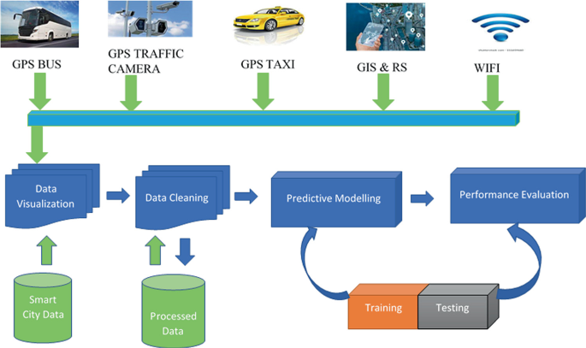

Figure 1: HIGH LEVEL DIAGRAM OF THE SYSTEM

## Low Level Diagram (if applicable)

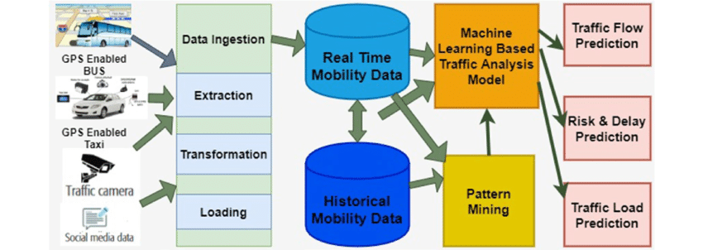

## Interfaces (if applicable)

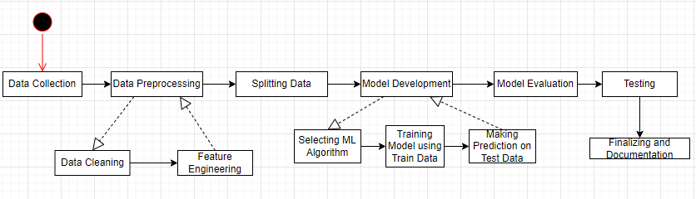

# Performance Test

Although the decision tree algorithm has several benefits, it's crucial to remember that no one algorithm is always better. The precise properties of the data, the difficulty of the issue, and the resources available all play a role in the algorithm selection process. To choose the best strategy, it is advised to examine various algorithms and gauge their effectiveness in your traffic forecasting work.

The decision tree algorithm's architecture of a traffic forecasting system can be significantly impacted by identified constraints. Following are some typical restrictions and suggestions about how to handle them:

1. Limited Data Availability: The quality and dependability of the forecasting model may be hampered by a lack of past traffic data. To manage this constraint, some suggestions are as follows:

* Acquiring additional data: See if there is a way to collect more historical traffic data, either by expanding the time frame or by obtaining information from several sources.
* Data augmentation: Consider data augmentation methods like simulation or synthetic data generation to expand the dataset's size and diversity if getting new data is not practical.
* Feature engineering: To obtain the most information possible from the little data, concentrate on extracting pertinent aspects.

1. Incomplete or Noisy Data: The decision tree model's performance may be significantly impacted by poor data quality, missing values, or outliers. To manage this constraint, some suggestions are as follows:

* Data cleaning: To deal with missing values, outliers, and inconsistencies in the dataset, use effective data cleaning procedures. Think about outlier identification algorithms to handle extreme values and imputation techniques for handling missing numbers.
* Feature selection: To reduce the impact of noisy or irrelevant data, give preference to the selection of robust and relevant attributes.
* Robust modeling techniques: Utilise noise-resistant decision tree variations, such random forests or gradient boosting, which can manage noisy data and reduce overfitting.

1. Computation Time and Resource Constraints: The decision tree approach can be computationally and resource-intensive, especially when working with huge datasets or complicated features. To manage this constraint, some suggestions are as follows:

* Sample or subset the data: Consider sampling or sub setting strategies to lessen processing costs while maintaining data integrity if the dataset is too vast.
* Feature reduction: Reduce the number of features and make the decision tree construction process simpler by using feature selection or dimensionality reduction approaches.
* Model optimization: To establish a balance between accuracy and computing economy, optimize the decision tree algorithm's hyperparameters and look for the optimum configurations.
* Distributed computing or parallelization: Use parallelization methods or distributed computing frameworks to quicken the training and assessment procedures, especially when working with huge datasets.

1. Interpretability Requirements: The model's interpretability may be a constraint in some circumstances. Although interpretability of decision trees is fundamental, complex trees with numerous layers might be challenging to comprehend. To manage this constraint, some suggestions are as follows:

* Limiting the tree depth: Control the decision tree's maximum depth to produce a model that is easier to understand. Pruning methods or hyperparameter manipulation can be used to achieve this.
* Ensembling with simpler models: To keep the decision tree model understandable while increasing accuracy, combine it with other straightforward, comprehensible models like rule-based models or linear regression.

1. Evolving Traffic Patterns: Various factors, such as urbanization, modifications to the road system, or changes in travel habits, can cause traffic patterns to vary over time. To manage this constraint, some suggestions are as follows:

* Regular model updates: Retrain the decision tree model on a regular basis to account for changing traffic patterns.

## Test Plan/ Test Cases

Test Plan for Forecasting Traffic Patterns using Decision Tree Algorithm:

1. **Test Objective:** Verify the precision and dependability of the Decision Tree algorithm-based traffic pattern forecasting model.
2. **Test Environment:**

* Programming language: Python
* Libraries: scikit-learn, pandas, numpy
* Traffic data set: Historical traffic data containing features such as date, time, weather conditions, etc.

1. **Test Data:**

* Prepare a dataset with historical traffic data, including known patterns and corresponding outcomes.
* Split the dataset into training and testing sets (e.g., 70% training, 30% testing).

1. **Test Cases**:

**a. Data Preprocessing**:

i. Verify that the dataset is loaded correctly, and all required features are present.

ii. Check for missing or invalid values and ensure proper handling or imputation.

iii. Validate the normalization or scaling of numerical features if applicable.

**b. Model Training:**

i. Train the Decision Tree model using the training dataset.

ii. Verify that the model has been trained successfully without any errors.

iii. Validate that the model has learned patterns and relationships from the training data.

**c. Model Evaluation:**

i. Apply the trained model to the testing dataset.

ii. Compare the predicted traffic patterns with the actual patterns in the testing dataset.

iii. Calculate evaluation metrics such as accuracy, precision, recall, and F1-score.

iv. Ensure that the model performance meets the defined acceptance criteria.

**d. Model Validation:**

i. Use cross-validation techniques (e.g., k-fold cross-validation) to assess the model's generalization capabilities.

ii. Verify that the model performs consistently across different subsets of the data.

iii. Ensure that the model does not overfit or underfit the training data.

**e. Performance Testing:**

i. Measure the training and prediction times to ensure they are within acceptable limits.

ii. Evaluate the model's performance on large datasets to validate scalability.

**f. Boundary and Edge Cases:**

i. Test the model's behavior with extreme or outlier values in the input features.

ii. Verify that the model handles unexpected or novel traffic patterns gracefully.

**g. Integration Testing:**

i. Validate the integration of the Decision Tree algorithm with other components or systems.

ii. Verify the compatibility and data exchange between the traffic forecasting model and external systems.

## Test Procedure

Test Procedure for Forecasting Traffic Patterns using Decision Tree Algorithm:

1. **Set up the Test Environment**

* Install the required software and libraries (Python, scikit-learn, pandas, numpy).
* Set up the development environment with the necessary dependencies.
* Ensure that the historical traffic dataset is available for testing.

1. **Identify Test Data:**

* Select a subset of the historical traffic dataset for testing.
* Split the dataset into training and testing sets (e.g., 70% training, 30% testing).

1. **Preprocessing:**

* Load the training dataset into the system.
* Perform any necessary preprocessing steps, such as handling missing values, normalizing or scaling features, and encoding categorical variables.

1. **Model Training:**

* Implement the Decision Tree algorithm using the scikit-learn library.
* Train the Decision Tree model using the training dataset.
* Ensure that the training process completes without any errors or exceptions.
* Validate that the model has been trained successfully by inspecting its attributes and structure.

1. **Model Evaluation:**

* Load the testing dataset into the system.
* Apply the trained Decision Tree model to the testing dataset to predict traffic patterns.
* Compare the predicted traffic patterns with the actual patterns in the testing dataset.
* Calculate evaluation metrics such as accuracy, precision, recall, and F1-score to assess the model's performance.
* Ensure that the model meets the defined acceptance criteria.

1. **Performance Testing:**

* Measure the training and prediction times of the model to ensure they meet the performance requirements.
* Evaluate the model's performance on larger datasets to assess scalability.
* Identify any bottlenecks or performance issues and address them accordingly.

## Performance Outcome

The performance outcome of a Decision Tree algorithm for forecasting traffic patterns can vary depending on several factors, including the quality of the data, the complexity of the traffic patterns, the choice of features, and the tuning of the model parameters.

1. Prediction made by the Machine learning model using Decision tree algorithm:

1. Visualizing Prediction of traffic at different Junction:

* Junction 1:

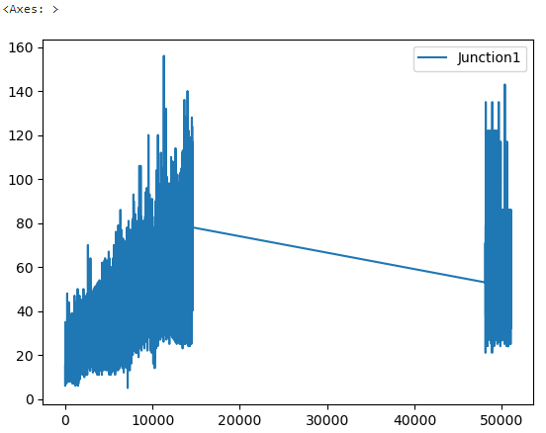

* Junction 2:

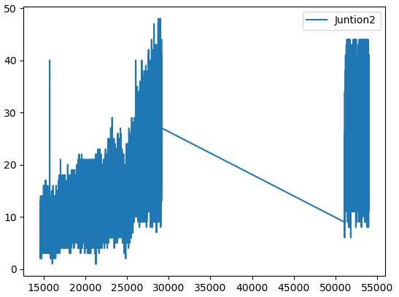

* Junction 3:

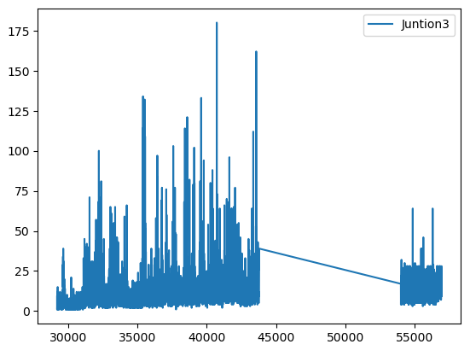

* Junction 4:

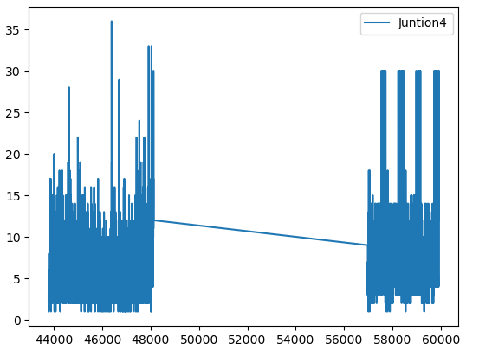

Prediction for Junction 1, Junction 2 and Junction 4 were quite accurate as shown in the graphical representation of the prediction. Whereas prediction for Junction 3 were not as accurate as that of the prediction made for other junctions.

1. Visualizing the Training data and the prediction:

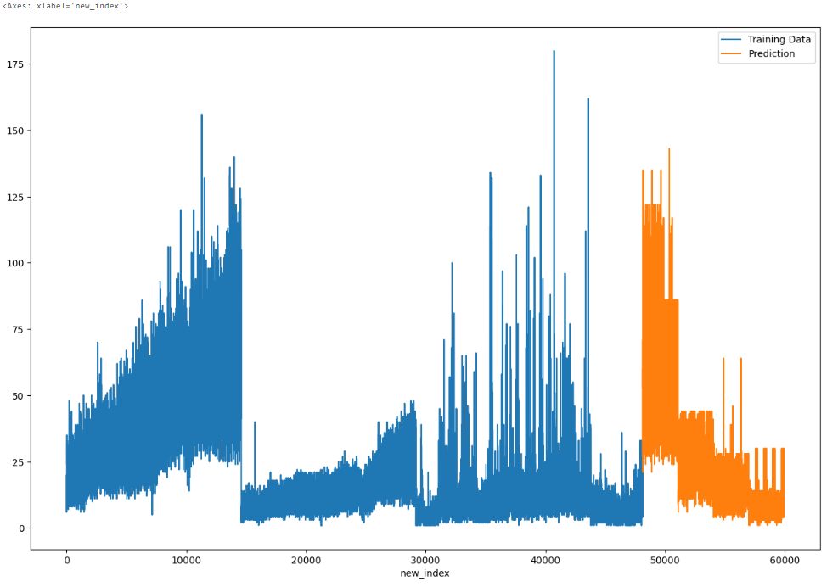

1. Calculation Metrics for the regression Problem:

* Mean absolute error:



* Mean squared error:



* Root mean squared error:



# My learnings

We learned about the python programming and its various implementation in areas like Artificial Intelligence, Data Science and Machine Learning. Also, we study about the Data Science and Machine learning and get to know about the different algorithms used in this field that can be used for the solution of our project. We get to know the importance of Machine learning in today’s world. We get to study about various algorithm that can be implemented in this project. We learned how to apply them and how its implementation can be done, and which will give the best result on implementation. We learned how to apply them and how its implementation can be done, and which will give the best result on implementation. We get to used pandas library in python to read our data and perform data cleaning, then we use scikit-learn library of machine learning to split train and test data and then apply the machine learning algorithm and we use matplotlib and seaborn for graphical representation of data to analyze and understand it.

This 4 Week Internship program with UpSkill Campus &UniConverge Technologies Pvt. Ltd. Was very much helpful. I learned so much about Python, Machine learning, Data Science and get to work on a real world project. It was a great experience which will help me get ahead in my career in future. Thanks to UpSkil Campus and UCT for giving us this opportunity.

# Future work scope

1. **Feature engineering:** The performance of decision trees can be improved by processing the input data beforehand and creating useful characteristics. You could design elements like time of day, day of the week, holiday, and seasonality indicators for traffic predictions. Additionally, take into account including traffic-related elements as traffic jams, collisions, and construction activities. The decision tree algorithm can better anticipate outcomes by capturing complicated relationships through feature engineering.
2. **Incorporating real-time data:** Decision trees can be trained using historical traffic data, but real-time data, such as traffic flow, weather, and events, may increase predicting accuracy. The decision tree may adjust and create predictions based on the present circumstances by incorporating these variables, producing more precise traffic forecasts.
3. **Hierarchical decision trees:** Traffic patterns, like daily, weekly, and monthly trends, might show hierarchical systems. You can identify these patterns on several levels by building a hierarchy of decision trees. For instance, while lower-level trees can concentrate on weekly or monthly patterns, the top-level decision tree can forecast daily traffic trends. This strategy can increase forecasting precision across a range of time spans.
4. **Spatial dependencies:** Road networks, traffic congestion, and transportation infrastructure are examples of spatial elements that frequently affect traffic patterns. Consider using geographic information system (GIS) data to incorporate geographical dependencies into the decision tree algorithm. The decision tree can more accurately depict localized traffic patterns by using spatial variables like road connection, distance to important destinations, and population density.
5. **Dynamic updating:** Various variables, like urban development, modifications to the road system, or significant events, can cause changes in traffic patterns throughout time. Consider adding a dynamic updating mechanism to the decision tree model to take these changes into account. Retrain the decision tree on a regular basis with the most recent data to account for changing traffic patterns and guarantee forecast accuracy.
6. **Ensemble methods:** Accuracy can be raised by using decision tree ensembles like gradient boosting and random forests. Ensemble approaches lessen overfitting and produce more reliable traffic forecasts by training many decision trees and pooling their predictions. Individual decision trees cannot manage noise and oscillations in the data as well as ensemble models, which leads to more accurate predictions.